|  |  |  |
| --- | --- | --- |
| Use case name:  **Search Timesheet** | | ID: Timesheet UC01 |
| Area: OOPMS System | | |
| Actor(s): Member , Project Manager | | |
| Description: This function allows users can search timesheet.  If user login with role member, user can search all timesheet of himself.  If user logins with role project manager, user can search all timesheet of all members in project. | | |
| Trigger Event: | | |
| Trigger Type: ⌧External 🞏Temporal | | |
| Steps Performed (Main Path) | Information for Steps | |
| 1. User go to Timesheet System main page |  | |
| 1. Choose filter and click Search |  | |
| Preconditions: N/A | | |
| Post-conditions: | | |
| Assumptions: | | |
| Requirement Met: | | |
| Outstanding Issues: | | |
| Priority: Medium | | |
| Risk: High | | |

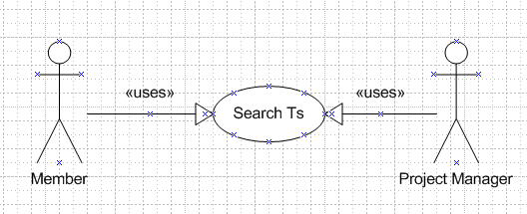

|  |  |  |
| --- | --- | --- |
| Use case name:  **Search Timesheet** | | ID: Timesheet UC01 |
| Area: OOPMS System | | |
| Actor(s): Member , Project Manager | | |
| Description: This function allows users can search timesheet.  If user login with role member, user can search all timesheet of himself.  If user logins with role project manager, user can search all timesheet of all members in project. | | |
| Trigger Event: | | |
| Trigger Type: ⌧External 🞏Temporal | | |
| Steps Performed (Main Path) | Information for Steps | |
| 1. User go to Timesheet System main page |  | |
| 1. Choose filter and click Search |  | |
| Preconditions: N/A | | |
| Post-conditions: | | |
| Assumptions: | | |
| Requirement Met: | | |
| Outstanding Issues: | | |
| Priority: Medium | | |
| Risk: High | | |

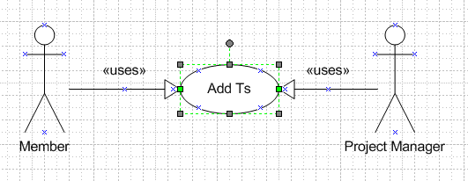

|  |  |  |
| --- | --- | --- |
| Use case name:  **Add Timesheet** | | ID: Timesheet UC02 |
| Area: OOPMS System | | |
| Actor(s): Member , Project Manager | | |
| Description: This function allows users can add a new timesheet record.  . | | |
| Trigger Event: | | |
| Trigger Type: ⌧External 🞏Temporal | | |
| Steps Performed (Main Path) | Information for Steps | |
| 1. User go to Timesheet System main page |  | |
| 1. Click Add new button |  | |
| Preconditions: N/A | | |
| Post-conditions: | | |
| Assumptions: | | |
| Requirement Met: | | |
| Outstanding Issues: | | |
| Priority: Medium | | |
| Risk: High | | |

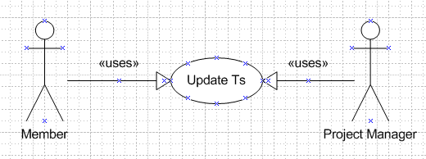

|  |  |  |
| --- | --- | --- |
| Use case name:  **Update Timesheet** | | ID: Timesheet UC03 |
| Area: OOPMS System | | |
| Actor(s): Member , Project Manager | | |
| Description: This function allows users can update timesheet record.  . | | |
| Trigger Event: | | |
| Trigger Type: ⌧External 🞏Temporal | | |
| Steps Performed (Main Path) | Information for Steps | |
| 1. Add timesheet list screen |  | |
| 1. User choose timesheet for updating by checking on checkboxes, click button Update |  | |
| Preconditions: N/A | | |
| Post-conditions: | | |
| Assumptions: | | |
| Requirement Met: | | |
| Outstanding Issues: | | |
| Priority: Medium | | |
| Risk: High | | |

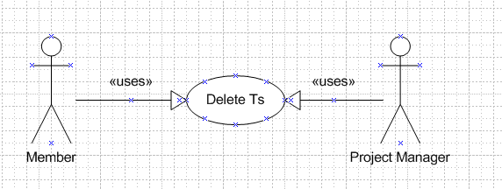

|  |  |  |
| --- | --- | --- |
| Use case name:  **Delete Timesheet** | | ID: Timesheet UC04 |
| Area: OOPMS System | | |
| Actor(s): Member , Project Manager | | |
| Description: This function allows users can delete timesheet record.  . | | |
| Trigger Event: | | |
| Trigger Type: ⌧External 🞏Temporal | | |
| Steps Performed (Main Path) | Information for Steps | |
| 1. Add timesheet list screen |  | |
| 1. User choose timesheet for deleting by checking on checkboxes, click button Delete |  | |
| Preconditions: N/A | | |
| Post-conditions: | | |
| Assumptions: | | |
| Requirement Met: | | |
| Outstanding Issues: | | |
| Priority: Medium | | |
| Risk: High | | |

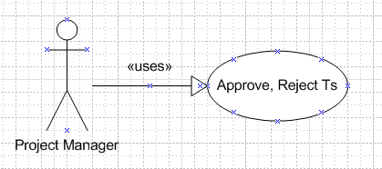

|  |  |  |
| --- | --- | --- |
| Use case name:  **Approve Reject Timesheet** | | ID: Timesheet UC06 |
| Area: OOPMS System | | |
| Actor(s): Project Manager | | |
| Description: This function allows users can change status of timesheet.  Has 3 status : approved, rejected and unapproved.  . | | |
| Trigger Event: | | |
| Trigger Type: ⌧External 🞏Temporal | | |
| Steps Performed (Main Path) | Information for Steps | |
| 1. Add timesheet list screen |  | |
| 1. User choose timesheet for updating status by checking on checkboxes, click button Approve or Reject |  | |
| Preconditions: N/A | | |
| Post-conditions: | | |
| Assumptions: | | |
| Requirement Met: | | |
| Outstanding Issues: | | |
| Priority: Medium | | |
| Risk: High | | |

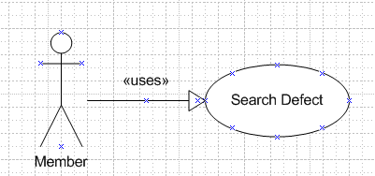

|  |  |  |
| --- | --- | --- |
| Use case name:  **Search Defect** | | ID: DMS UC01 |
| Area: OOPMS System | | |
| Actor(s): Member | | |
| Description: This function allows users can search defect.  Defect has 3 kinds : open defect, closed defect, leakage | | |
| Trigger Event: | | |
| Trigger Type: ⌧External 🞏Temporal | | |
| Steps Performed (Main Path) | Information for Steps | |
| 1. User go to DMS System main page |  | |
| 1. Choose filter and click Search |  | |
| Preconditions: N/A | | |
| Post-conditions: | | |
| Assumptions: | | |
| Requirement Met: | | |
| Outstanding Issues: | | |
| Priority: Medium | | |
| Risk: High | | |

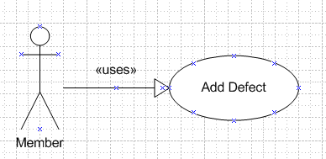

|  |  |  |
| --- | --- | --- |
| Use case name:  **Add Defect** | | ID: DMS UC02 |
| Area: OOPMS System | | |
| Actor(s): Member | | |
| Description: This function allows users can add defect.  When defect was added, member become creator, defect change status to opened | | |
| Trigger Event: | | |
| Trigger Type: ⌧External 🞏Temporal | | |
| Steps Performed (Main Path) | Information for Steps | |
| 1. User go to DMS System main page |  | |
| 1. Choose filter and click button add defect |  | |
| Preconditions: N/A | | |
| Post-conditions: | | |
| Assumptions: | | |
| Requirement Met: | | |
| Outstanding Issues: | | |
| Priority: Medium | | |
| Risk: High | | |

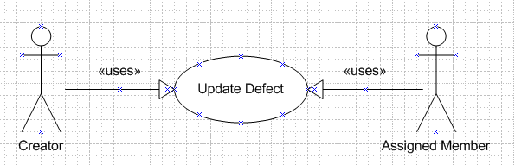

|  |  |  |
| --- | --- | --- |
| Use case name:  **Update Defect** | | ID: DMS UC03 |
| Area: OOPMS System | | |
| Actor(s): Creator, Assigned Member | | |
| Description: This function allows users update status, description, cause, corrective action of defect  Creator can change status of defect from opened to cancelled or corrected.  Assigned member can change status of defect to opened, canceled or closed. | | |
| Trigger Event: | | |
| Trigger Type: ⌧External 🞏Temporal | | |
| Steps Performed (Main Path) | Information for Steps | |
| 1. User go to Defect detail page |  | |
| 1. Update info of defect and click button update |  | |
| Preconditions: N/A | | |
| Post-conditions: | | |
| Assumptions: | | |
| Requirement Met: | | |
| Outstanding Issues: | | |
| Priority: Medium | | |
| Risk: High | | |

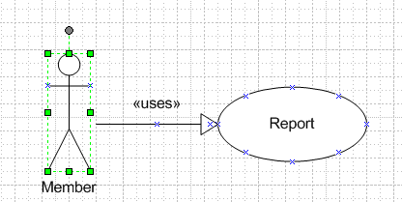

|  |  |  |
| --- | --- | --- |
| Use case name:  **Update Defect** | | ID: DMS UC04 |
| Area: OOPMS System | | |
| Actor(s): Creator, Assigned Member | | |
| Description: This function allows users make report of defects | | |
| Trigger Event: | | |
| Trigger Type: ⌧External 🞏Temporal | | |
| Steps Performed (Main Path) | Information for Steps | |
| 1. User go to DMS System main page |  | |
| 1. Choose filter and click Search |  | |
| Preconditions: N/A | | |
| Post-conditions: | | |
| Assumptions: | | |
| Requirement Met: | | |
| Outstanding Issues: | | |
| Priority: Medium | | |
| Risk: High | | |